
www.kingston-saddlery.com
QUALITY ALWAYS WINS
875 STILLWATER ROAD SUITE 200 WEST SACRAMENTO, CA 95605
Phone: (916)996-0711 Fax: (530)753-4505
E-mail: kingstonsaddlery@yahoo.com & sales@kingston-saddlery.com

ASSEMBLY OF THE CARRIAGE

INSTALL BODYWORK ------------------------------------------------------------------------------------------

Groupware ------------------------------------------------------------------------------------------------------

Installation ------------------------------------------------------------------------------------------------------

INSTALL SEAT -----------------------------------------------------------------------------------------------------

Groupware ------------------------------------------------------------------------------------------------------

Installation ------------------------------------------------------------------------------------------------------

INSTALL SHAFT ---------------------------------------------------------------------------------------------------

Groupware ------------------------------------------------------------------------------------------------------

Installation ------------------------------------------------------------------------------------------------------

Accomplishment -----------------------------------------------------------------------------------------------

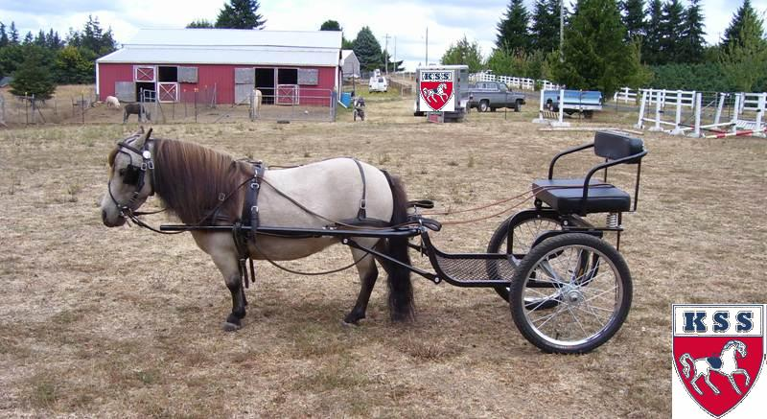
Product code: C2201.45

Remark:

Color: Black
Strong, rugged design with expanded metal floor, comfortable cushioned seat for kid with a backrest. Open design for easy entry and exit (can appended railing). Chrome rim 20" wheels. Metal shafts standard. Third extra wheel to lighten load of dog. A cart will be send with one carton.
1、INSTALL BODYWORK

GROUPWARE
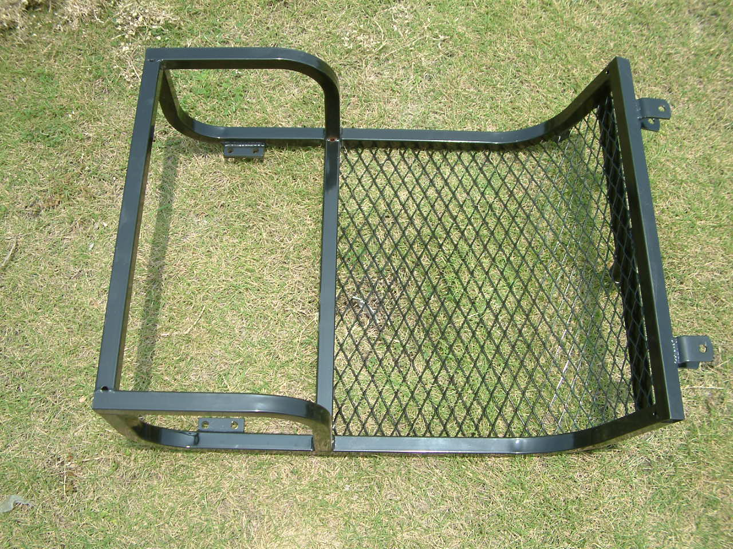 |  | 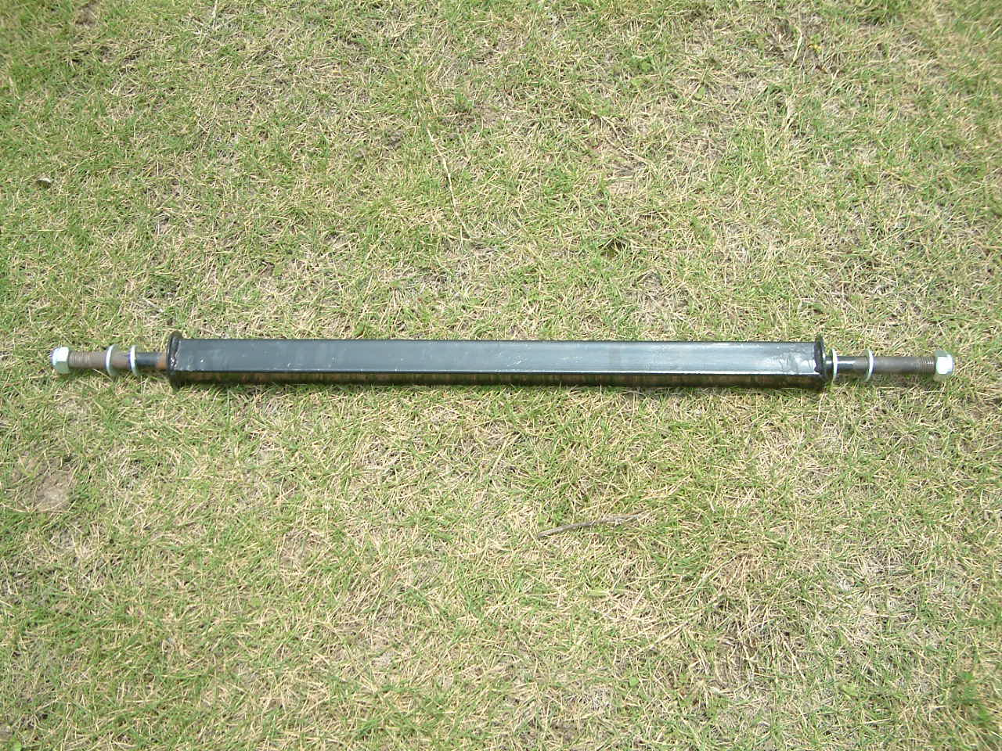 |  | 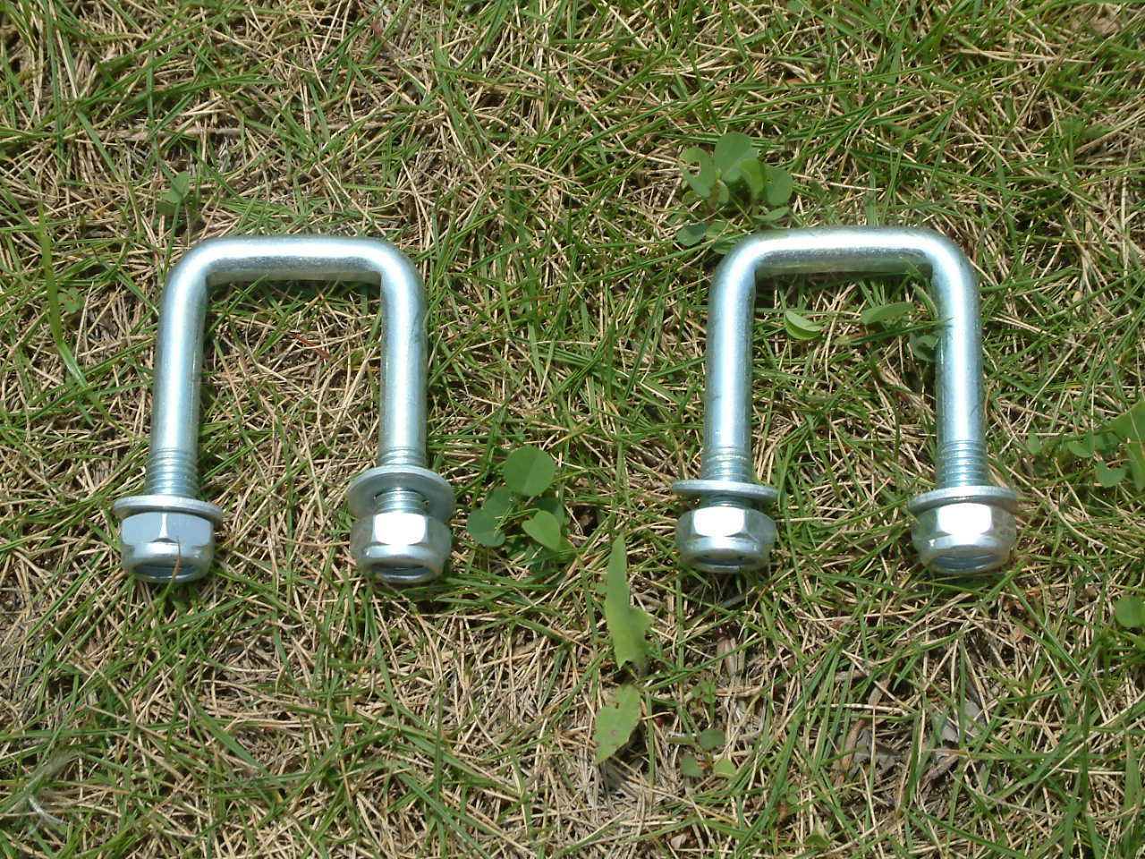
（1）BODYWORK |  | （2）AXLE |  | （3）U-STYLE TIGHTEN PIECE (×2)
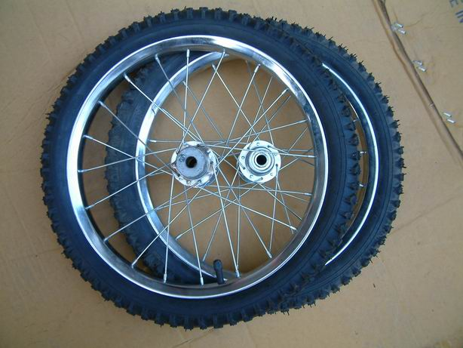 | 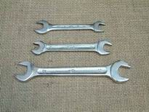
（4）WHEELS |  | （5）ACCESSORIES: A SET OF 3 SPANNERS
INSTALLATION
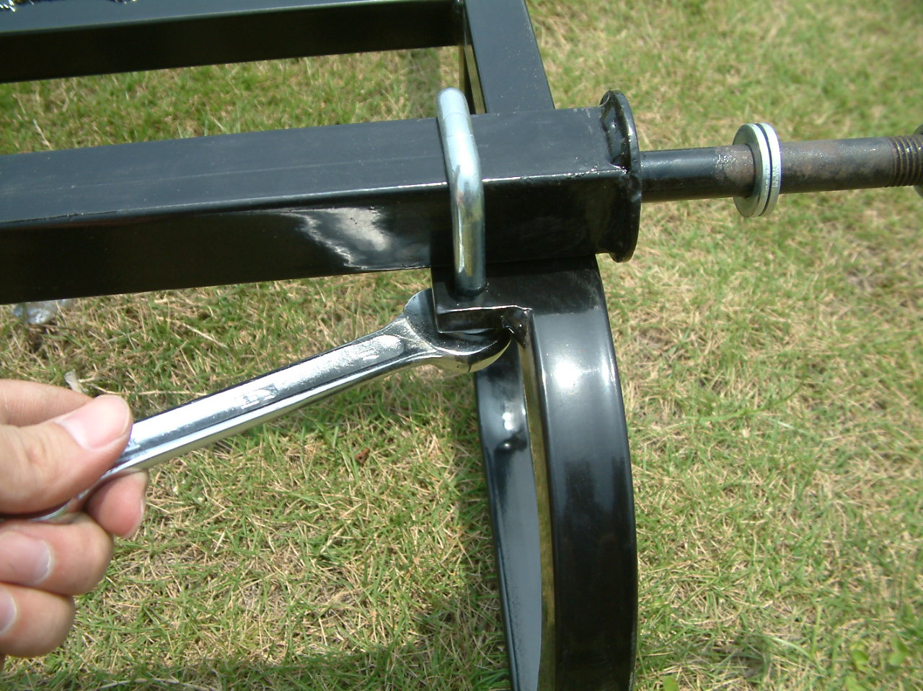 |  |  | 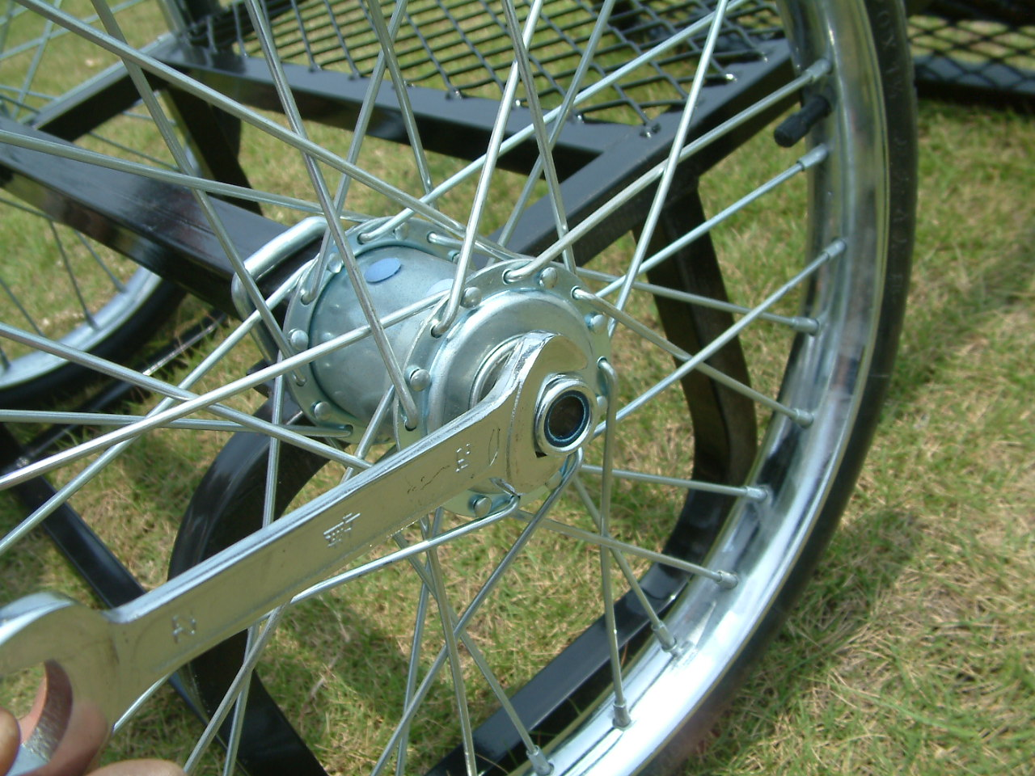
Tighten (2) into (1) by (3) with spanner. |  |  | Again put the washer on the axle outside, and tighten it with the nut.

2、INSTALL SEAT

GROUPWARE
 | 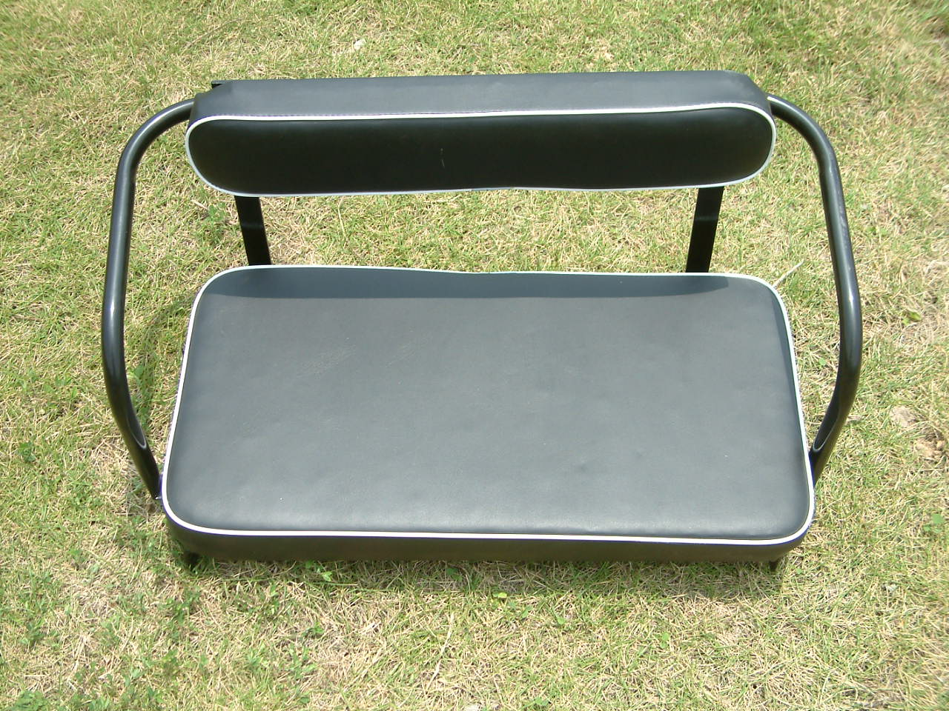 | 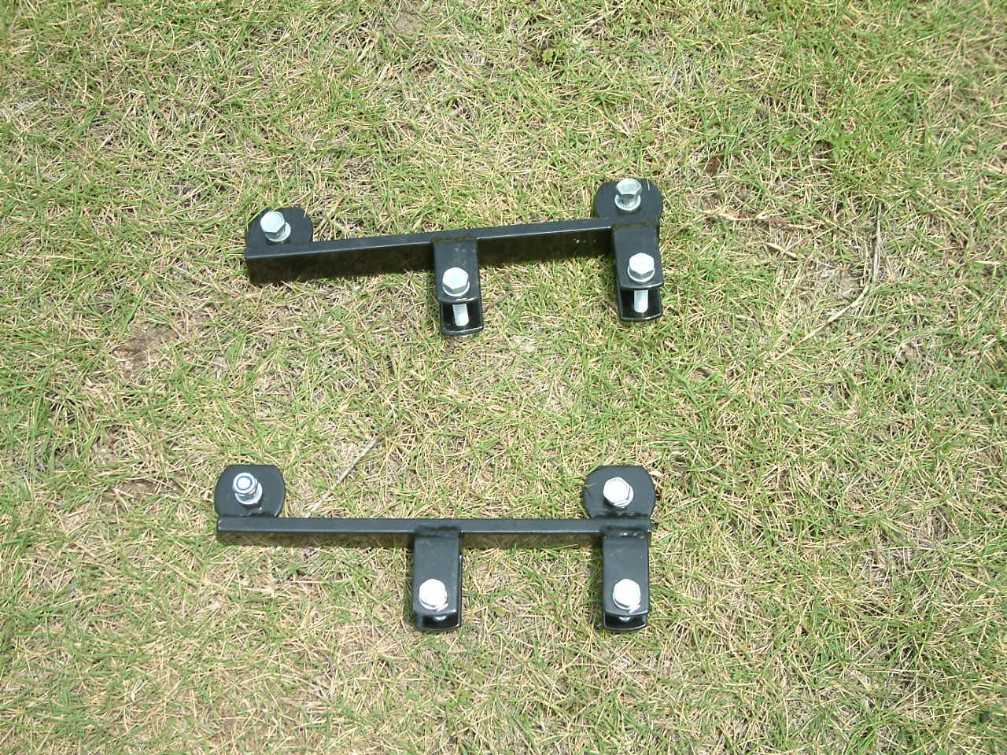
（1）BODYWORK | （6）SEAT） | （7）SEAT CONNECTION AND SUSTAINTATION PIECES（×2）
INSTALLATION
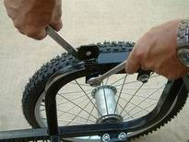 | 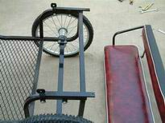 | 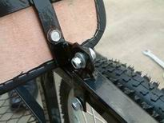
Fix one side of (7) on the horizontal frame of the (1) by nut, and tighten it with spanner. | Fix the other side of（7） | Fix the transverse nut of (6) with (7). NOTICE: NOT SO TIGHTEN
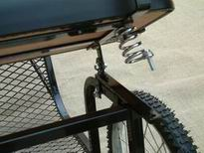 | 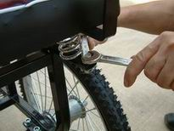 | 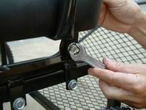
Set the bolt to the anti shake spring of (6), revolve (6) so that the bolt can be put into the hole of (7) | Fix the nuts on lengthways. | Fix the transverse nut.

3、INSTALL THE SHAFT

GROUPWARE
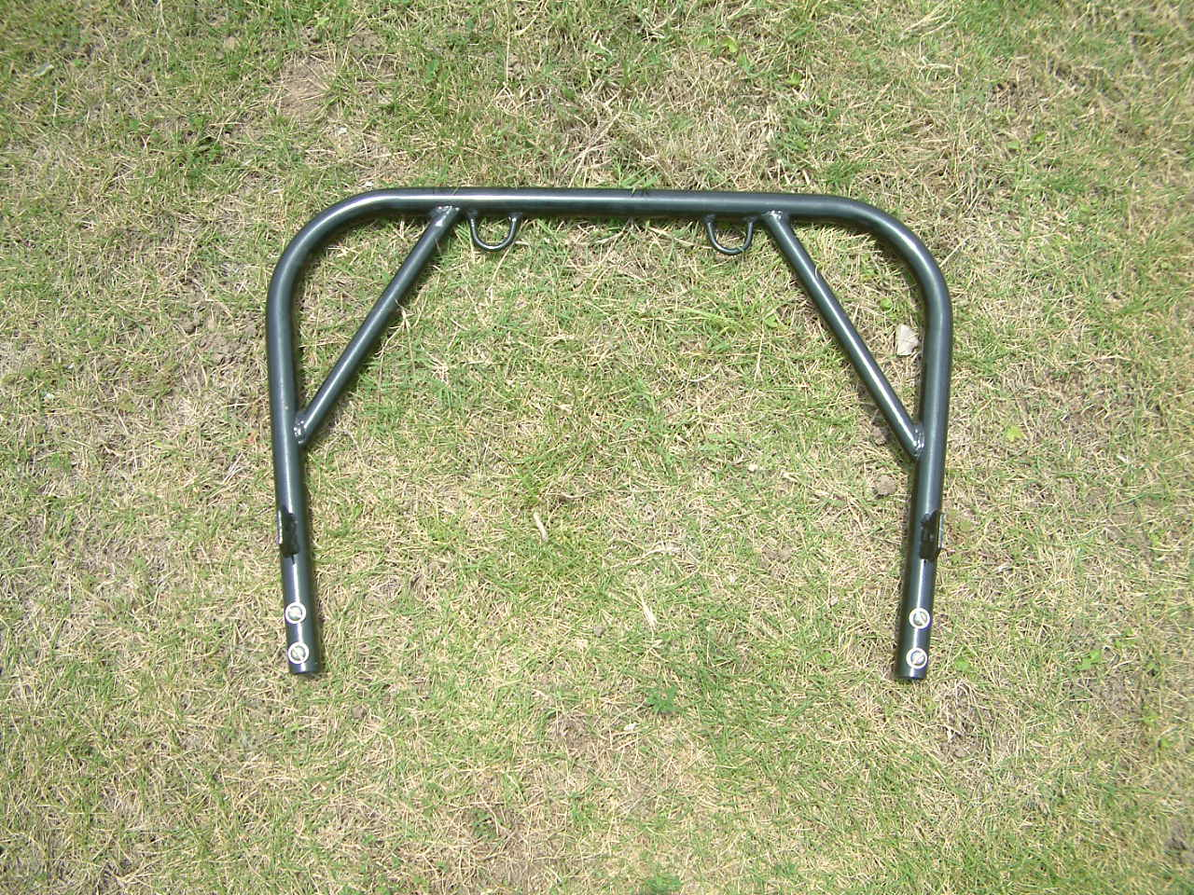 | 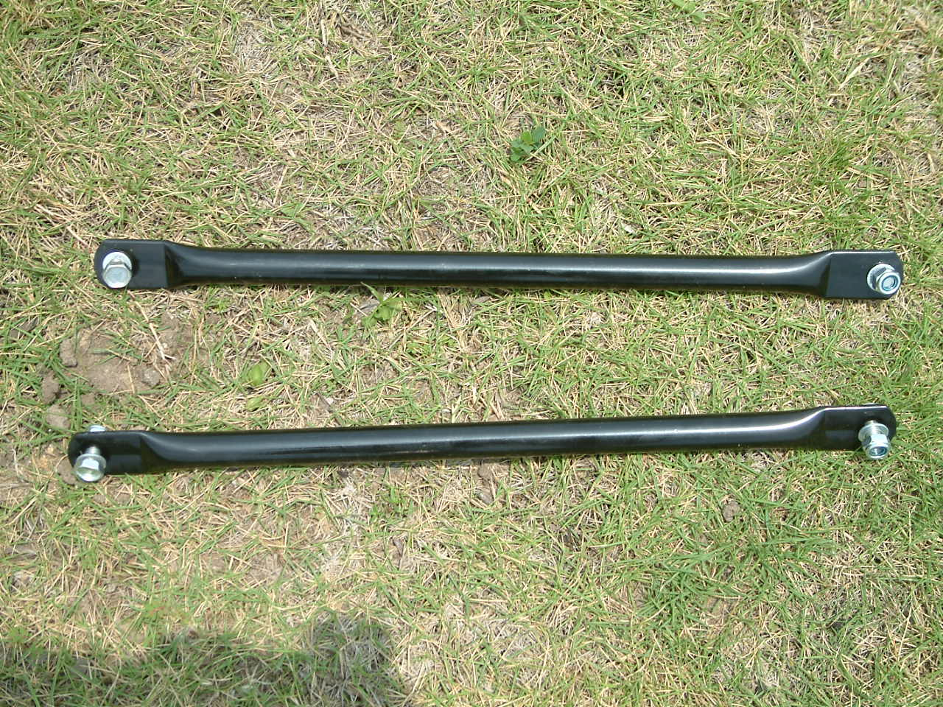 |  | 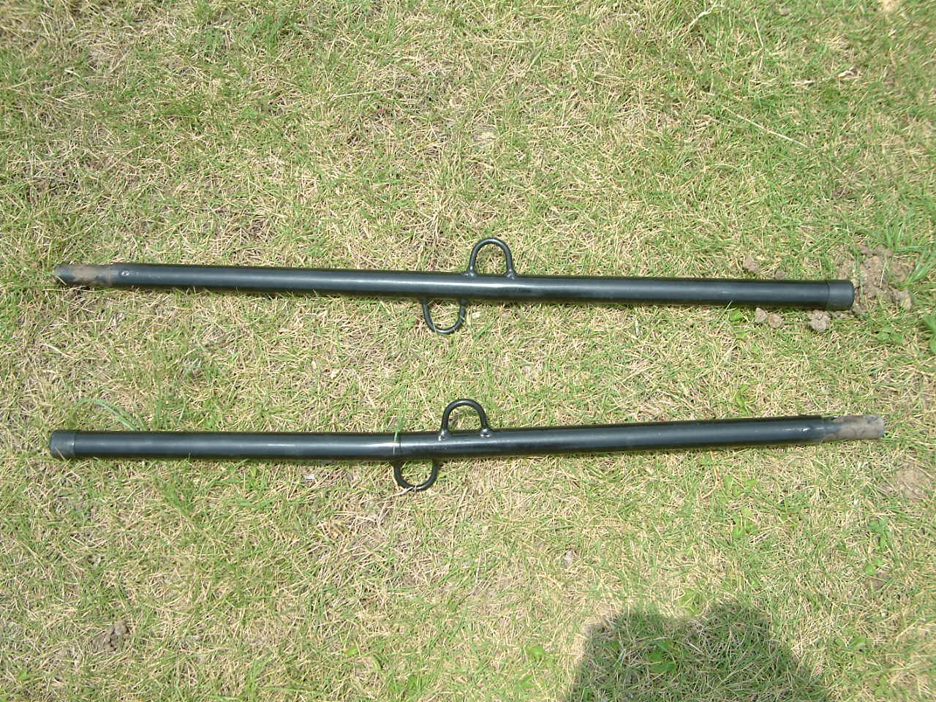
（8）SHAFT part I | （9）SHAFT part II |  | （10）KNIGHTHEAD OF SHAFT
INSTALLATION
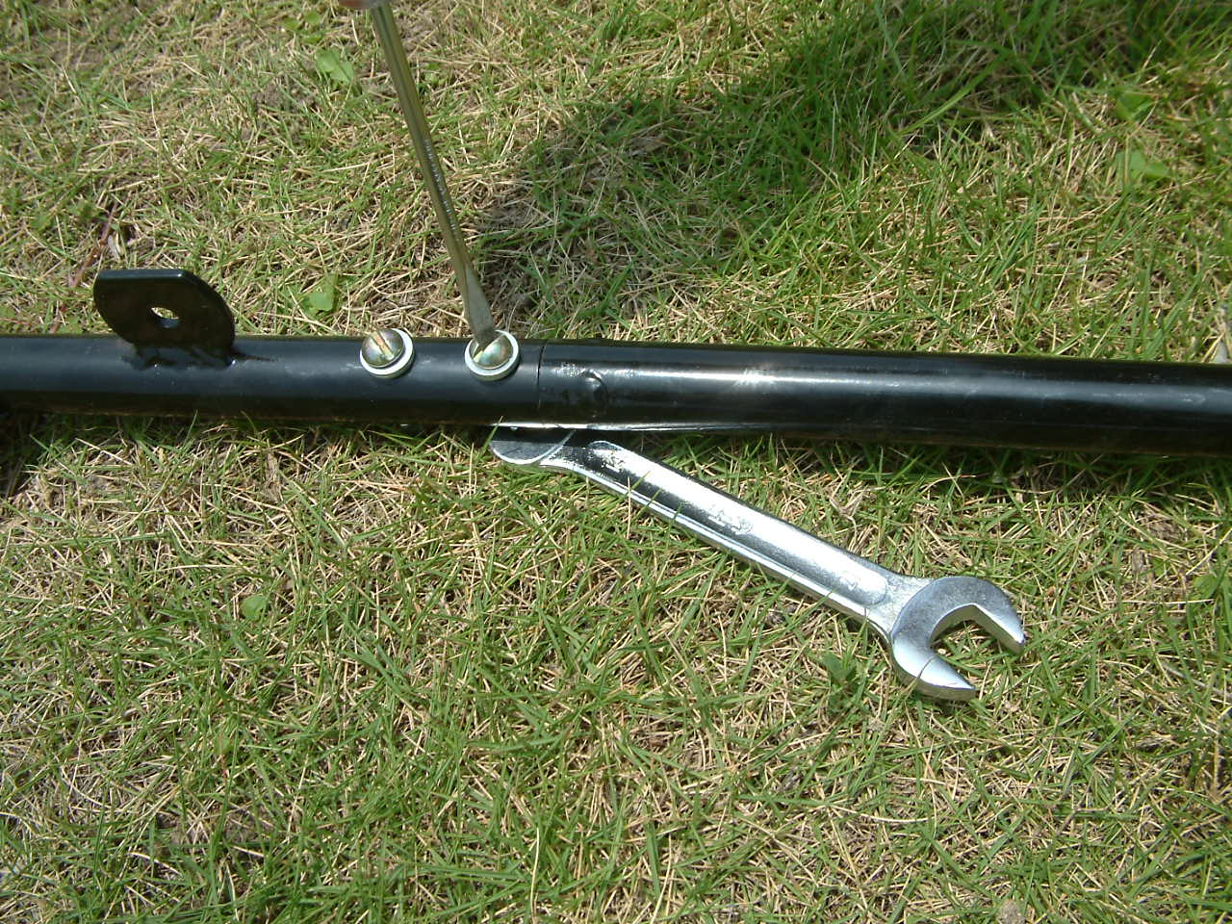 |  | 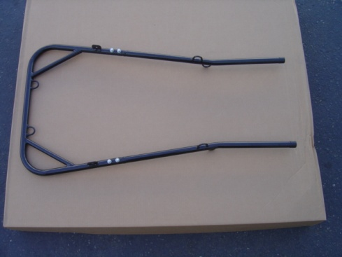
Join the （8）and （10）with bolt and nut by tools |  | Finished shaft
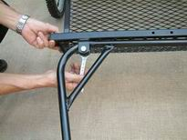 |  | 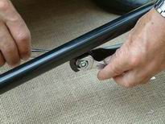
Tighten the shaft with bodywork by bolt and nut |  | Tighten the （9）with bodywork and shaft by bolt and nut
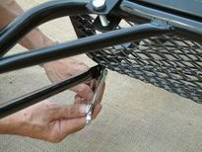
Tighten the （9）with bodywork and shaft by bolt and nut

4、INSTALL THE TURNING BAR

GROUPWARE
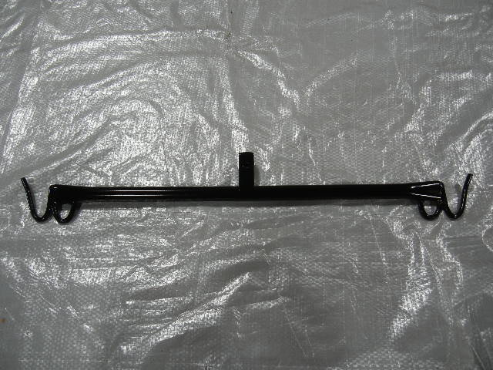 | 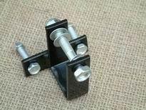
（11）TURNING BAR | （12）BAR CONNECION
INSTALLATION
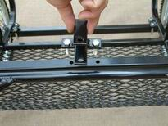 | 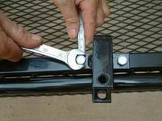
Fix (12) on the front rail of bodywork by bolt. | Tighten（12）
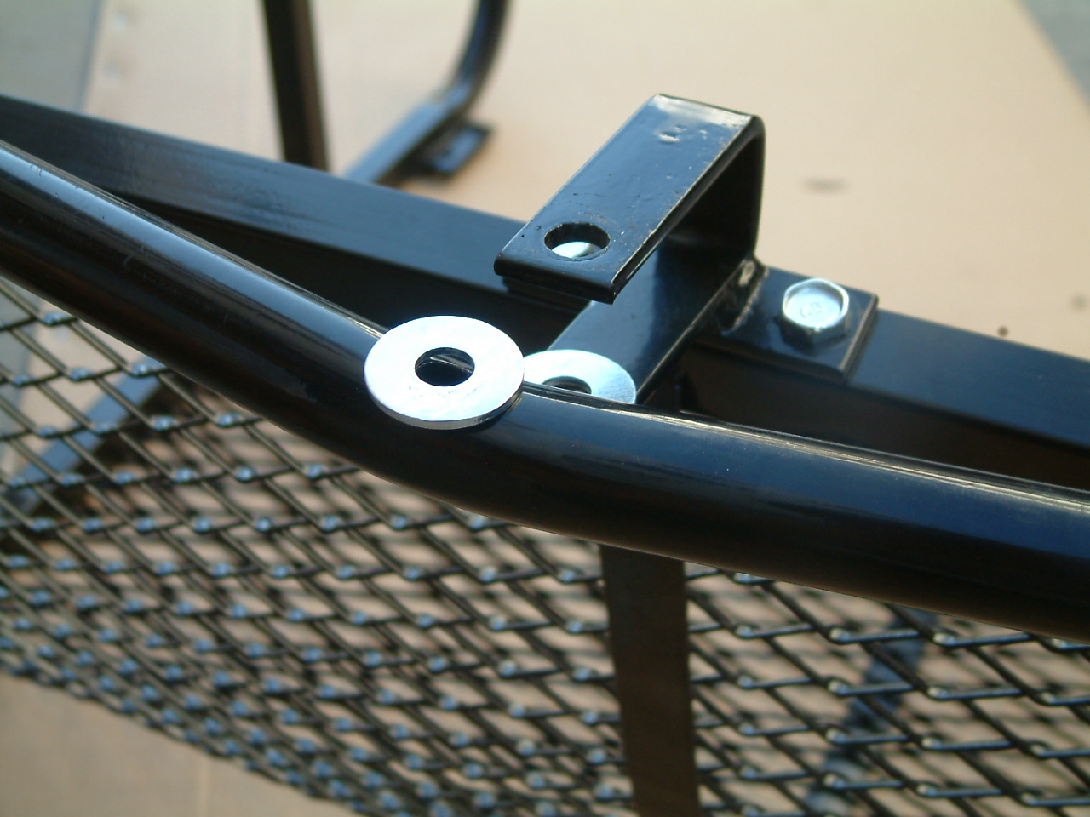 | 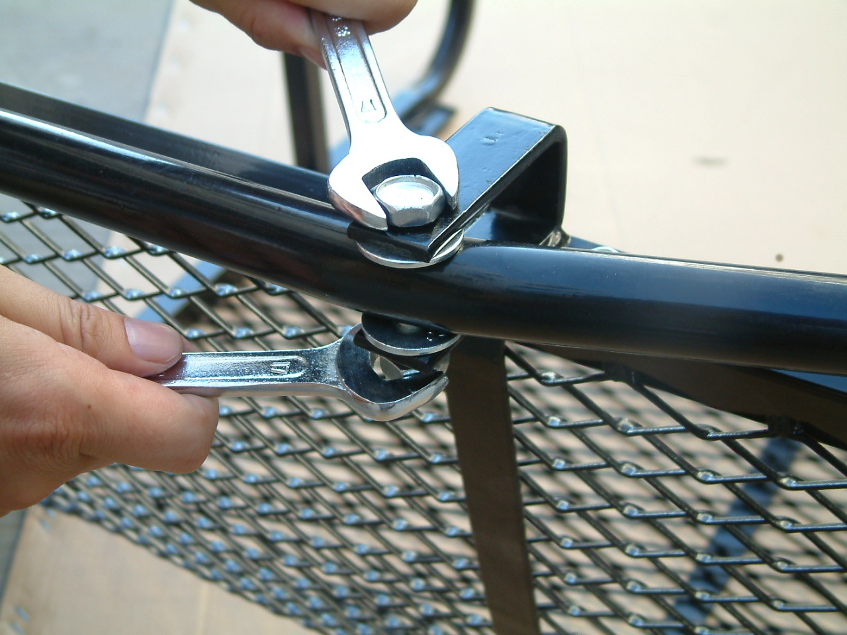
Add two washers on the top and bottom of the (11), put them into the groove (12). | Tighten (11) and (12)  NOTICE: NOT SO TIGHT TO MAKE SURE THE TURNING OF (11).

FINISHED PICTURE

